ASSINGMENT – 23

Inserting a row usig procedure

CODE:

create or replace procedure p_dept is

p_dept_id departments.departmentid%type;

p_dept_name departments.departmentname%type;

begin

p_dept_id:=1;

p_dept_name:='AI&DS';

insert into departments(departmentid,departmentname)

values(p_dept_id,p_dept_name);

end;

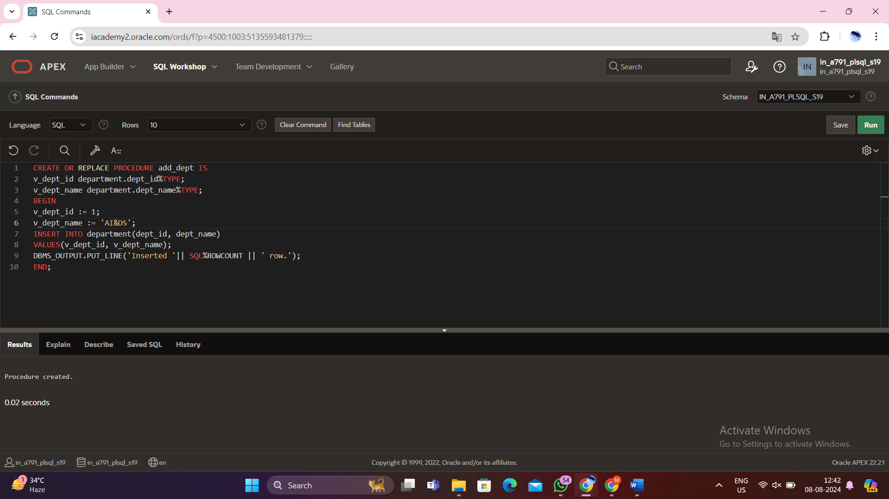

Begin

Add_dept;

End;

/

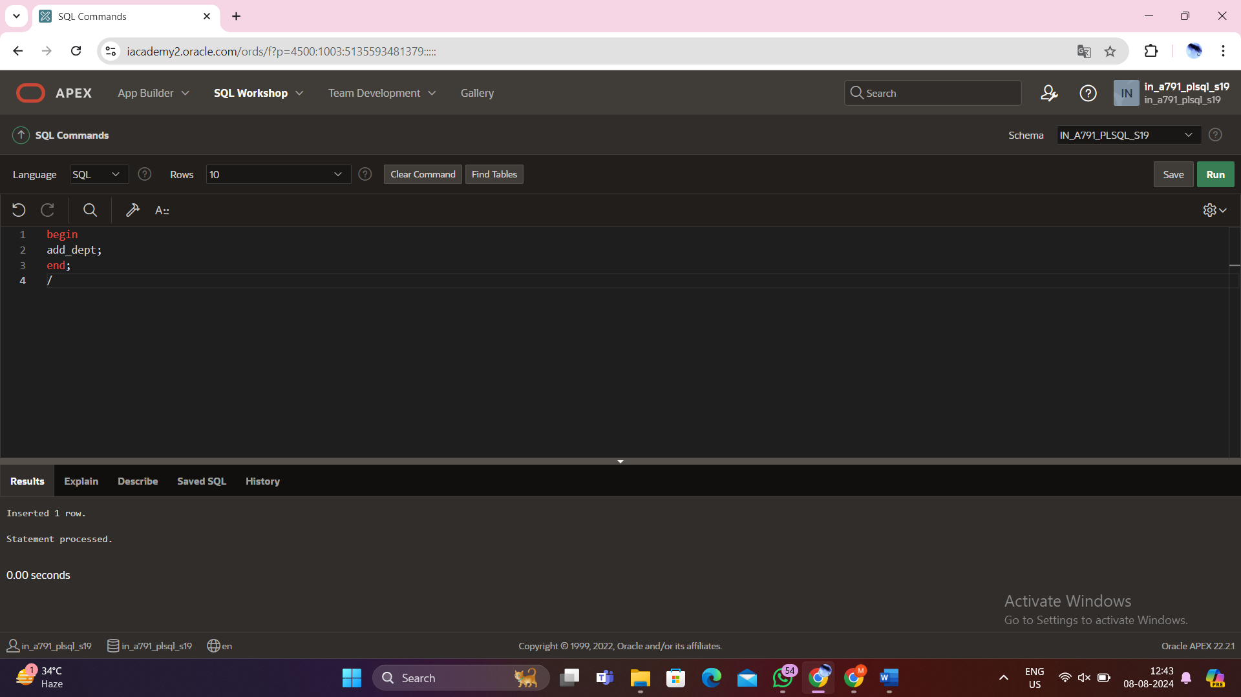

Output:

Select * from department;

